**Report Homework 6**

1. Introduction

* In this homework, we have to implement an algorithm to find out the Longest Common Subsequences.

1. Methodology

* There are three main parts in this homework, building table c, table b, and print out process.
* Table c is used to track the length of the common subsequence of the two sequences.
* During building table c, we also can build table b which contains 3 kinds of arrows, left (⬅), up(⬆), and up-left (↖).
* The final function is print, this function will take advantage of table c to find out the common number recursively. By comparing the value of b[i][j] with up-left, if they are equal, it means that x[i] is a common number.

|  |
| --- |
|  |
| Figure : The figure shows how the algorithm works. |
| **Function Print()**    Figure : Print_out function.  Building table c and b    Figure : Building tables b and c. |

**Results**

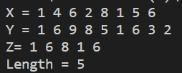

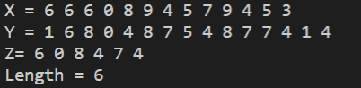

|  |
| --- |
|  |
|  |
|  |
|  |
|  |
|  |
|  |

From the results above, the longest time of running is when n=11 and m=11 with two numbers in common. The fastest result is n=3, m = 3 with 1 in number in common. Although the lower number of n and m could send out a shorter time of finding, the two sequences that have no number in common also spend quite a bit long time to finish the algorithm.

* With the help of this algorithm, the time complexity is decreasing from O(2n ) to O(m*n).